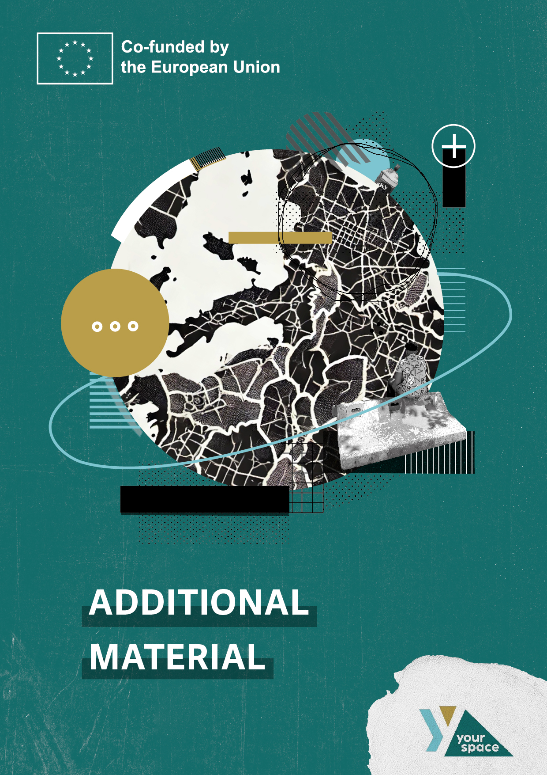

Abstract

This paper introduces the *Persona Game*, an interactive exercise that support the **process of engaging in creative partnerships.** As a core part of the *Training Modules*, the game focuses on two key groups: youth with dreams and potential, and the artists, teachers, or mentors who guide them. Through a fictional matchmaking process, players are prompted to challenge their assumptions, uncover blind spots, and explore new opportunities in supporting the artistic development of their protégés.

Rooted in design thinking, the *Persona Game* uses Personas—fictional characters that represent different stakeholders. These personas are developed through research-based insights into real-life experiences, behaviours, and needs, offering valuable perspectives on the individuals we aim to support.

Primarily aimed at social youth workers, the game applies methods from the *Your Space* project and aligns with the **principles of social space orientation** **and open child and youth work**. It focusses on empathy, reflective practice, and cross-sector collaboration between cultural educators, artists, and youth workers. By complementing the *Your Space* training modules, the game helps participants refine their educational profiles, align expectations, and develop shared goals for effective collaboration.

Ultimately, the *Persona Game* promotes flexibility, openness, and meaningful engagement, creating **synergies for creative partnerships** and participatory learning in youth work.

This document includes detailed instructions, a practical walkthrough, and downloadable materials for easy implementation.

**Publisher & Project Coordination**

BGZ Berliner Gesellschaft

für internationale Zusammenarbeit mbH

www.bgz-berlin.de

**Authors**:

Outreach, BGZ

**Source of Picture(s):**

Own materials

**Content**

The Persona Game: An Overview & Demonstration 1

1. What is the Persona Game? 1

2. Persona Developments 2

3. Persona Examples: Youth Participants 3

4. Persona Example: Youth Facilitators 5

5. Wheel of Power and Privilege 7

6. Finding opportunities for Creative Partnerships 9

Phase 1 – Walkthrough: Defining a meaningful collaboration 10

Phase 2 – Walkthrough: Engaging with youth 11

Short Summary 12

How to play the Persona Game: Step-by-Step 13

1. Preparation and Overview 13

2. Playthrough: Activities and Exercises 14

Annex: Game Material 18

1. Playing Cards 18

2. Blueprint Persona Analysis Table 19

3. The Wheel of Power and Privilege 20

# The Persona Game: An Overview & Demonstration

## What is the Persona Game?

The **Persona Game** is a **role-playing game (RPG)** designed to facilitate the planning and implementation of **social-artistic projects** with young people facing disadvantage or discrimination. It serves as a practical tool for applying the methods and scenarios used and demonstrated within the *Your Space* project. The game is primarily designed for social youth workers engaging with highly diverse groups of young people and underlies the guiding principles of social space orientation and open child and youth work.[1]

Its key objectives include fostering empathy-building and reflective practices, strengthening cross-sectoral collaborations between cultural educators, artists, and youth workers, and ultimately enhancing the impact of cultural youth education in youth work. The Persona Game complements hereby the self-assessment exercises provided in the *Your Space* training modules, offering an interactive and immersive learning experience. It is therefore recommended to do the **self-assessment exercises** first before playing the Persona Game.

The Persona Game can be a rewarding onboarding-exercise that ideally takes place prior to the initiation of partnerships and collaborations between cultural educators from pedagogic and creative professions, cultural institutions, or other relevant backgrounds. It takes time and patience, especially at the beginning of network formation, to become aware of the differences and synergies of each other’s approaches, and to gain an understanding for the values, principles, forms of interaction, beliefs, and attitudes that guide each other’s actions.

When taken seriously and aligned with the guiding principles of youth work, the Persona Game helps social youth and cultural organisations refine their educational profile by identifying strengths and assessing opportunities for effective, engaging, and complementary collaboration. By shifting perspectives, the game supports creative partnerships in defining their position, aligning expectations, establishing common guidelines, and developing shared principles and goals for cross-sectoral collaboration and networking within educational landscapes.

In Summary, in open child and youth work, success depends on coordinating diverse strengths, pedagogical approaches, and expertise to effectively engage young people. This requires openness to different educational methods and a willingness to adapt. Cultural institutions and artists must embrace the flexible structures of youth work, connect meaningfully with young people, and share their art with passion and professionalism. True collaboration in cultural education thrives when institutions act as open laboratories, moving beyond rigid course structures to foster inclusive, participatory learning. The *Persona Game* supports this process by exploring fictional scenarios where social workers, cultural institutions, and artists can align their methods and create synergies, ultimately engaging into creative partnerships.

## Persona Developments

The Persona Game starts with players collaboratively elaborating a pool of detailed persona descriptions that represent two different groups: **youth participants and facilitators** of cultural education programs – ideally, they develop narratives with references from their educational practice that describe how these personas will (or won’t) interact with the program in real life. These stories add context and transform the personas into blueprints for the design of programs that meet the nuanced needs of different user types.

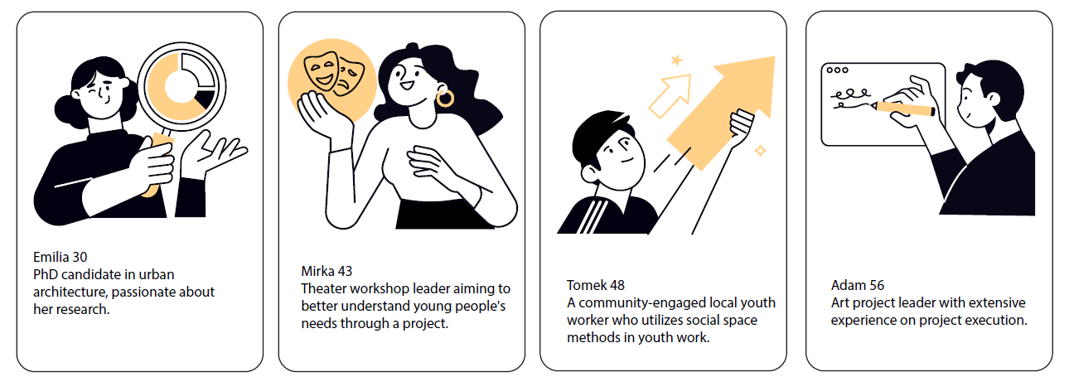

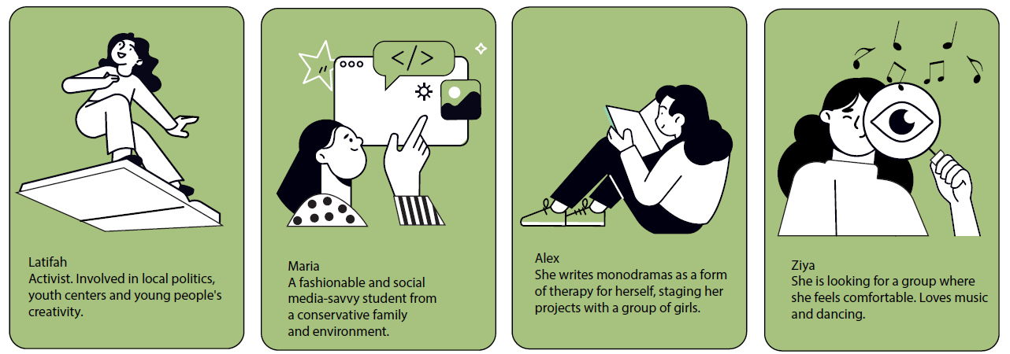

By developing detailed persona descriptions, players gain insights into the varied backgrounds and experiences of youth participants and facilitators, fostering empathy, awareness, and understanding. If the fictional characters do not represent the context you are working in, you can customise them and have them match the characteristics of young people and facilitators that you encounter in your everyday pedagogical practice. Use the categories on the backside of the cards as guidelines for the description of your personas.

(TIP: Also include personas who are not (yet) using your service or who you have difficulties to reach).

After developing Personas for both Youth Participants and Youth Facilitators, the game prompts you to analyse them using key guiding questions. The insights can be structured in a pre-made table to highlight:

* **Strengths:** What skills and qualities do they bring?
* **Limitations:** What challenges might they encounter?
* **Interests:** What are they passionate about? Do they have specific goals or agendas?
* **Relationships:** Who do they connect with in their community?
* **Preferred Role in the Group:** Where would they thrive?
* **Life Motto:** A guiding principle or core belief.

This analysis helps deepen understanding and enhances collaborative planning.

## Persona Examples: Youth Participants

Here are two exemplary youth participants

**Persona 1: Amina**

Amina, 19, is a young Muslim woman residing in a communal accommodation center in a challenged neighborhood with her parents and an older sibling. Five years ago, her family fled the war and found refuge in your country. She balances traditional attire, including a hijab, with modern makeup and jewelry, reflecting her cultural heritage and personal expression. Often, she would be the only one wearing the hijab. Her native languages are Dari and Farsi. She is taking German for beginners classes and understands a tiny little bit of English. Facing challenges such as a temporary residence permit, limited upward mobility, and language barriers, she actively seeks opportunities to overcome these obstacles. Together with her teacher from fashion school, Amina reaches out to apply for a mandatory 3-weeks internship at the local youth organization. The teacher discovered Amina’s passion for fashion design, content creation and photography through her vlog.

**Persona 2: Omar**

Omar, 18, was born in your country. His family has Kurdish roots. Back home he’s considered a foreigner, in your country he’s considered a migrant. Two hearts are beating in his chest. He struggles belonging. He grew up in a tough social housing area and became delinquent when he was 16 years old. After 10 months in juvenile detention, Omar is referred to the local youth organization to report for community service. In the beginning, he regularly misses out on appointments, shows little motivation or initiative, is very distant, and comes late. He keeps up a hypermasculine facade of coolness to come across strong and signal that he is tough. When he discovers the organisations music studio and learns about the regular rap workshop, his mood and attitude are lightening up. He tells the supervisor that writing rap lyrics can be very therapeutic and plays him one of his songs. His lyrics reflect deeply about his time in juvenile detention, having failed the education system, his mum, risky drug use, and all the challenges that come along with this lifestyle.

**Analysis of the Youth Participants based on the guiding questions:**

|  |  |  |
| --- | --- | --- |
|  | **Omar** | **Amina** |
| **Strengths** | * Rap lyricism, * lived experience (juvenile detention, social housing), * awareness of social issues, * potential for leadership (if channeled positively), * bilingual (Kurdish dialect + German). | * Strong sense of resilience and determination, overcoming the challenges of displacement and cultural adaptation. * Passionate about self-expression through fashion design, photography, and content creation. * pride in her Iranian Afghan heritage. * Creative and resourceful, using available resources to pursue her interests, |
| **Limitations** | * Delinquent/Criminal past, * hypermasculinity, * mistrust of authority, * potential drug use, * lack of formal education, * struggles with belonging, * internalized racism and prejudice. | * Faces language barriers, which limits her ability to fully integrate. * Has a temporary residence permit, adding uncertainty to her prospects. * struggles with feelings of being an outsider in her new country. * Sometimes feels torn between her cultural identity and the pressure to adapt to mainstream societal norms. |
| **Interests** | * Rap music, * expressing himself through lyrics, * exploring his identity, * finding belonging, * addressing social issues, * challenging authority (in a constructive way). | * passionate about fashion design and photography, with a particular interest in using these mediums to express her cultural identity. * Enjoys creating digital content, including her own vlog, which gives her a platform to showcase her voice and creativity. * Interested in exploring new forms of artistic expression, particularly those that bridge cultural gaps. * Curious about learning new skills that could enhance her career prospects and help her navigate her new life in a foreign country. |
| **Relationships** | * Youth workers (initially wary), * fellow inmates (potentially negative influence), * his mother (potentially strained), * others in the social housing area, * potential connection to rap community. | * Strong familial bond with her parents and older sibling, who share in her journey of adaptation and survival. * Connected with an activist community of young women from similar refugee backgrounds. * Mentored by local cultural workers, who have recognized her potential and encouraged her to pursue her artistic interests. * Builds connections with other young people through creative projects, strengthening her network and sense of belonging. |
| **Favourite role** | * Lyricist/performer, * social commentator, * peer mentor, * youth advocate. | * using her skills in photography and content creation to inspire others. * Prefers roles where she can express her unique perspective and help others share their stories, such as in collaborative art projects or workshops. |
| **Life motto** | * use your voice to speak truth. * find strength in the struggle. * don’t forget where you come from | * She uses art as a tool for self-expression, healing, and building stronger community ties, all while embracing both her cultural heritage and her new environment. |

## Persona Example: Youth Facilitators

Here are two exemplary youth Facilitators

**Sergio**

Sergio, 48, a former drama teacher, secures funding for an arts project with “disadvantaged” youth—hoping to bridge his income gap while sharing his passion for theatre. Coming from a white, middle-class academic background, he pitches his preconceived theatre play to schools, youth centres, and social workers to recruit participants from a multicultural, socially challenged neighbourhood.

In a meeting with local youth workers, it becomes clear that Sergio lacks experience with marginalised youth. His project, designed without their input, appears misaligned with the values of youth work and offers no real decision-making power to participants. The youth workers see it as exclusive rather than genuinely inclusive.

Struggling to gain interest, Sergio resorts to paid ads and posters. When the project launches, only three young people attend—none from the demographic it was intended to support.

**Julia**

Julia, 35, is a dedicated social worker with over a decade of experience in arts-based youth education, specializing in working with multicultural and refugee communities. She designs programs that combine creative expression with practical skill-building, helping young people explore their identities, strengthen their voices, and build confidence.

Her approach blends formal social work training with a deep appreciation for artistic methods. Over time, she has learned to balance structured program goals with the flexibility young people need to experiment and express themselves. She actively seeks feedback to refine her methods, ensuring her programs remain relevant and impactful.

A key turning point came when she co-created a community art exhibition with local youth, allowing them to take the lead in shaping the project. This experience reinforced the importance of youth-driven initiatives, showing her how creative freedom fosters genuine engagement and empowerment. Today, Julia continues to develop inclusive programs, collaborating with local youth workers to amplify young people's voices and ensure their perspectives shape the educational process.

**Analysis of the Youth Participants based on the guiding questions:**

|  |  |  |
| --- | --- | --- |
|  | **Sergio** | **Julia** |
| **Strengths** | * Technical expertise in theater production and project management. * Access to institutional networks (e.g., funding bodies, cultural venues) | * Skilled at blending formal social work with creative, non-formal education. * Strong intercultural sensitivity and self-awareness * Builds trust with youth through active listening and co-creation. * Advocates for youth-led decision-making and cultural representation |
| **Limitations** | * Views youth as “disadvantaged” rather than “expert” collaborators. * Cultural Unawareness: Unfamiliar with youth’s lifeworld and everyday aesthetics (e.g., rap, TikTok). * Rigid, top-down approach | * Struggles to balance structured program goals with youth’s spontaneous needs. * May over-rely on traditional arts-based methods (e.g., photography) without fully integrating youth cultures |
| **Interests** | * Professional recognition and replicating past theatrical successes. * Savior Complex: Wants to “uplift” marginalised youth through high art | * Creating programs that bridge cultural divides and empower marginalized voices. * Using art for healing, identity exploration, and community-building |
| **Relationships** | * Hierarchical: Engages with institutions (schools, funders) more than communities. * Struggles to relate and connect with youth peers | * Collaborates with migrant organizations, local artists, and youth activists. * Acts as a mediator between institutions (e.g., schools) and grassroots communities |
| **Favorite role** | * Visionary Director: Prefers controlling creative outcomes (e.g., scripting plays) rather than promoting co-creation | * Facilitator-Mentor: Creates safe spaces for youth to lead while she provides the scaffolding |
| **Life motto** | * Believes traditional theater is inherently transformative, regardless of context. * Deficit Mindset: Sees youth as lacking skills vs. recognizing their cultural assets | * Believes art is a tool for social justice and belonging, not just skill-building. * Prioritizes intersectionality |

## Wheel of Power and Privilege

To gain an even deeper understanding of a Persona, we recommend applying the concept of intersectionality, as outlined in the Training Modules. Analysing a Persona through this lens helps identify societal norms, structures, and processes that reinforce the marginalisation of young people or reproduce power imbalances. These factors can significantly impact how creative partnerships are formed and sustained.

We suggest first playing the game without incorporating the Wheel of Power and Privilege. Then, in a second run, apply the wheel to observe how relationships shift and new approaches emerge within the creative partnership. Below is an overview of how Youth Participants can be positioned within the wheel. You find the Wheel of Power and Privilege in the Annex.[2]

Example Analysis of Amina based on the Wheel of Power and Privilege

Amina's positioning on the Wheel would likely be influenced by several intersecting factors:

* **Citizenship:** As a refugee with a temporary residence permit, Amina lacks equal rights and access to certain resources. Her refugee status limits her upward mobility.
* **Skin Colour:** As a person of colour, she is a regular subject to racism, prejudices, insulting, stereotyping, othering, stigmatizing, devaluation, racial profiling.
* **Gender:** Identifying as female, Amina is subject to sexism and patriarchy worldviews
* **Religion:** Proudly wearing the hijab, she visually identifies as Muslima and experiences stigmatization, biases, anti-muslimism, stereotyping
* **Name:** Every time she’s asked to repeat her name; she is reminded of being an outsider. Due to her last name, she also must write significantly more job applications.
* **Age:** At 19, Amina is transitioning from adolescence to adulthood, which has an influence on societal perceptions of her and the expectations that follow with her maturity.
* **Housing:** Living in communal accommodation places her at a certain periphery on the wheel concerning her socioeconomic status. The challenged social housing area she is residing in confronts her daily with crime, violence, drug abuse, homelessness, poverty, and other forms of social hardship.
* **Wealth:** because of their refugee status and limited work permits the family depends on support from welfare services. That limits Amina’s possibilities to earn extra money and become independent.
* **Education:** Having the possibility to pursue a fashion and design traineeship
* **Physical/Mental Health:** Outwardly she displays resilience and is eager to overcome the challenges of displacement and cultural adaptation. Sometimes she struggles to belong and feels as an outsider. The uncertainty of her residence status regularly triggers anxiety states. She might still be traumatised.
* **Language:** her limited knowledge of the German and English languages is a barrier

## Finding opportunities for Creative Partnerships

A crucial aspect of effective youth cultural education is recognising and leveraging diverse perspectives. By developing a pool of facilitator personas that embody various educational approaches, we create opportunities **for meaningful cooperation**. The diversity of these approaches offers valuable insights into how programs can be tailored to meet the unique needs and backgrounds of different target groups.

In the next step, **players engage with different facilitator personas, assessing how their methods complement or contrast with others**. While some approaches may enhance youth engagement and learning, others might not provide significant value. Through a critical examination of these personas—considering diversity-conscious and anti-discriminatory principles—players refine their understanding of educational strategies and sharpen their own professional profiles.

Youth facilitators are tasked with developing an approach for working with young people in a specific context. Creating scenarios where facilitator personas must collaborate under the guiding principles of youth work provides a valuable learning experience. **You can orientate on the Scenarios within the Your Space Project.** These simulations encourage participants to reflect on how diverse approaches interact—sometimes leading to challenges but often resulting in innovative partnerships.

Through these exercises, youth workers can explore strategies for bridging differences and harnessing diversity to create more effective and inclusive educational programs. This hands-on learning method equips practitioners with the skills needed for real-world collaborations, ultimately enhancing the quality of youth cultural education.

After developing a concept or method for working with youth on a specific topic—based on the youth persona facilitator`s personal and professional background—it is time to engage with the youth participants. Facilitators present their ideas and integrate the input and personal needs of the youth into the implementation process. For instance, some participants may need to develop specific skills before they can fully engage with the facilitators’ concept, or they may face limitations due to their personal backgrounds.

At this stage, players redistribute their roles into at least two facilitators and two youth participants. Together, they reflect on how to implement their ideas while simultaneously fostering the hidden talents and interests of the youth.

By critically examining these approaches through a diversity-conscious and anti-discriminatory lens, players refine their understanding of educational strategies, sharpen their professional identities, and ultimately create a culturally responsive approach tailored to the individual needs of the youth.

### Phase 1 – Walkthrough: Defining a meaningful collaboration

**A possible walkthrough on the basis of the Persona`s Julia & Sergio looks like this:**

Julia hopes to build on the success of her community art exhibition by incorporating additional cultural activities. When she comes across Sergio’s advertisements and posters, she reaches out, and they agree to meet. During their conversation, Sergio pitches his idea for a theatre play aimed at helping “disadvantaged youth” integrate into society. While Julia appreciates the idea of a theatre project, she quickly realises that Sergio’s approach is too simplistic and disconnected from the realities of the marginalised youth she works with. She explains to him the principles of open child and youth work.

To bridge this gap, Julia suggests taking a step back and organising icebreaker sessions with local youth to explore their interests and see if a theatre project resonates with them. Sergio agrees, and together they design engaging, inclusive activities to introduce the idea.

Following these sessions, it becomes clear that the youth are interested in theatre but lack experience in writing structured plays. However, they bring a wealth of ideas and perspectives. Leveraging his technical expertise, Sergio organizes small working groups based on their thematic interests. Meanwhile, Julia, drawing on her experience in blending formal social work with creative non-formal education, introduces the concept of hybrid performances—combining urban art forms with theatrical storytelling.

To deepen engagement, Julia and Sergio plan additional workshops tailored to specific interests. A local migrant organization photographer offers street photography sessions, helping participants capture the vibrancy of their neighbourhood. A well-known rapper leads songwriting and performance workshops, encouraging youth to explore social issues through rap lyrics. Julia suggests hosting these sessions in community spaces like parks and youth centres to create an accessible and welcoming atmosphere.

As the youth develop their performances, securing a platform for them to showcase their work becomes crucial. Sergio leverages his institutional network to arrange a performance space in a theatre. While Julia acknowledges the benefits of a professional venue, she worries it might feel intimidating. To build confidence and trust, she proposes a series of smaller rehearsals where friends, family, and community members can provide feedback, allowing the youth to refine their performances in a supportive setting. These gatherings become spaces for intergenerational and intercultural dialogue, further enriching the project.

Sergio also works with local stakeholders to secure funding for costumes, props, and technical equipment, ensuring a high-quality production. Through their collaboration, Julia and Sergio successfully create a theatre project that is not only artistically meaningful but also deeply rooted in the lived experiences and creative aspirations of the youth.

On opening night, the performance is a resounding success. The stage comes alive with vibrant visuals, powerful rap performances, and heartfelt spoken-word pieces that reflect the lived experiences of the youth. The audience includes not only young people but also families, educators, and community leaders who are moved by the authenticity and creativity of the production.

The project’s impact extends beyond the stage. It fosters a sense of belonging among participants, strengthens community ties, and challenges preconceived notions about theatre as an art form. By prioritizing youth input and embracing their cultural expressions, Julia and Sergio demonstrate how participatory arts can empower young people to tell their stories while bridging divides within their community.

### Phase 2 – Walkthrough: Engaging with youth

**A possible walkthrough on the basis of the Persona`s Julia & Sergio looks like this:**

When introduced to the idea of a theatre play, Amina is initially overwhelmed. Cultural expectations and language barriers make the thought of performing on stage intimidating. However, Julia’s approach of integrating urban art forms into the project sparks an idea—Amina realizes she can express herself in a way that doesn’t rely on language. Proud of her Iranian-Afghan heritage and passionate about fashion, she decides to create a cultural fashion show. This allows her to showcase the beauty of her traditions while asserting her identity as a newcomer to the country.

Julia encourages the idea, recognizing its potential to ease the pressure of adapting to mainstream societal norms and instead celebrate Amina’s individuality. Sergio also sees the opportunity and helps organize costumes and materials through his connections with the theatre. Despite her excitement, Amina is hesitant when she learns they will be performing in a professional theatre. Julia’s idea of rehearsals with family and friends helps her build confidence. Encouraged by this support, Amina invites a group of young women from a refugee activist community to join, expanding the fashion show to represent multiple cultures. Omar, on the other hand, rejects the idea of performing a play—he finds it ridiculous and unappealing. However, Sergio, with his visionary mindset, and Julia, with her mentoring skills, help him see the broader creative potential. They show him that a performance can be a stepping stone to other artistic pursuits, skill development, and even new opportunities. Inspired by this perspective, Omar realizes he can use the project as a platform to showcase his rap skills. He becomes excited about writing and performing a new song, hoping to record it and gain recognition. However, as he works on his music, Omar struggles to align his lyrics with the production, and his motivation begins to wane. To support him, Julia and Sergio bring in a professional rapper to lead songwriting workshops. These sessions reignite Omar’s passion, helping him refine his craft and complete a powerful song for the final performance. Julia provides emotional support, guiding him in channeling his experiences and emotions into his lyrics—turning art into a tool for self-expression, healing, and identity exploration.

### Short Summary

The Persona Game is a practical tool designed to support the development and refinement of professionally tailored programs that address specific needs within a given context. It helps align your strategic focus with the lived realities of your target audience. By using the Persona Game as an onboarding exercise in new collaborations, you can professionally assess to what extent the educational approaches of potential partners align with the core principles of youth work, as well as the needs and interests of the target group. To ensure youth work principles remain central, it’s vital to make educational practices visible. Facilitator personas help illustrate common challenges and successes in youth cultural education, while encouraging participants to share their own experiences enriches the learning process. This exchange enhances understanding and promotes collective growth in the field. Working with personas allows youth workers to reflect on their strengths and areas for improvement, forming the foundation for ongoing professional development. Ultimately, this approach supports the creation of a more inclusive, cooperative, and high-quality educational environment that meets the diverse needs of young people. This is still an oversimplified example. Please notice, the more you engage with this exercise, the deeper you can delve into the details. Its purpose is to provide a real-life understanding of how to engage in cultural partnerships and assess whether certain ideas align with the interests of young people—or not. The Persona Game helps to incorporate challenges young people face in their everyday lives, which may not be immediately visible. The Persona Game is not a standalone solution; rather, it complements the existing tools, skills, and competencies that youth facilitators already possess.

# How to play the Persona Game: Step-by-Step

## Preparation and Overview

|  |  |
| --- | --- |
| **Prerequisites** | |
| There are no strict prerequisites for playing the Persona Game. However, it is recommended that at least one player has experience working with youth in an informal setting. Additionally, having a project idea you’d like to develop with your protégés or colleagues can enhance the experience. The game requires time and commitment, as it consists of a series of structured exercises. These activities should be completed in chronological order (1–5), with Activity 4 being optional for those who wish to add extra analytical depth to the personas.  For the best experience, it is recommended to play with at least four participants. This not only makes the game more engaging but also brings in diverse perspectives, better reflecting real-life scenarios where groups are rarely homogeneous. It is also recommended to be creative when developing personas—exaggeration and even the use of stereotypes can be helpful. This approach creates friction, making challenges more pronounced and facilitating deeper discussions within the group. We also strongly suggest to try to keep in the timeframe for each exercise. | |
| **For whom is the game** | |
| This game is designed for anyone who wants to work with young people from diverse backgrounds and contexts. It is especially recommended for social workers interested in incorporating art or cultural activities into their youth projects. | |
| **Duration** | You can use the Persona Cards as examples / inspiration (Green) |
| **Number of players** | 2-8 (recommendation, but there is no general limit) |
| **Materials** | 10 Facilitator cards (yellow), 20 youth cards (green), Blue print table: “Persona Analysis”, Wheel of Power and Privilege to be downloaded on the [Your Space webpage](https://yourspace-project.eu/ergebnisse/). |
| **How to start** | |
| Print the Playing Cards and the Blueprint tables in a sufficient number depending on the number of players. Use for the Playing Cards an A3 Format, this makes it easier to work with the cards. | |

## Playthrough: Activities and Exercises

|  |  |
| --- | --- |
| **Activity 1: Developing Youth Participants** | |
| Develop a pool of detailed youth persona descriptions that provide a comprehensive image and understanding of their "Lebenswelt" (own environment). Describe the context(s) you meet them in. Reflect on socio-demographic aspects, everyday cultural and aesthetic practices, diets and habits, privileges, and characteristics of the community the persona is embedded in. What are their problems, needs, and interests? Identify strengths, limitations, communicative links, and possible ways to address them. Use the tables and self-assessment exercises from the training modules. | |
| **Type of work** | **Group or Individual Work** |
| **Approximate Time** | **25 min** |
| **Materials needed** | You can use the Persona Cards as examples / inspiration (Green) |
| **Guiding questions** | |
| * How likely are they going to participate in the program voluntarily? * What are their interests? * What are they passionate about? * Can you identify ways to address them? | |
| **TIP**: If you are already a social worker or have direct contact with young people, you can use them as inspiration—while ensuring anonymity by changing names if needed. Consider creating more than one youth participant for a broader perspective. While it's not necessary to analyse every participant in detail, focusing on one in greater depth is highly recommended for a more meaningful exploration. | |

|  |  |
| --- | --- |
| **Activity 2: Developing Youth Facilitators** | |
| Develop a pool of detailed persona descriptions of actors that might be involved in the facilitation of our fictional cultural youth education program.Include descriptions of people from pedagogic and creative professions, cultural institutions, or other relevant backgrounds. Describe their professional backgrounds, attitudes, skills, approaches, and their relationship with the youth. | |
| **Type of work** | **Group or Individual Work** |
| **Approximate Time** | **25 min** |
| **Materials needed** | You can use the Persona Cards as examples / inspiration (White) |
| **Guiding questions** | |
| * How do they navigate non-formal and informal education challenges? * Do they critically reflect on and improve their practices? * Can they engage diverse youth groups? * Do they demonstrate intercultural sensitivity and self-awareness? * How do they motivate young people? * Are they flexible in adapting to youth interests? * Are they familiar with youth culture, communication, and aesthetics? * Do they recognise and amplify young people’s cultural expressions? * Do they design relevant, needs-based programs? * Do they align with social space orientation principles in youth work? * Are they civically engaged and advocates for youth work values? | |
| **TIP**: Consider not only traditional social workers, but also individuals you may want to collaborate with, such as artists or professionals from the creative sector. This broader perspective can enrich your approach and bring diverse skills and ideas into the project. | |

|  |  |
| --- | --- |
| **Activity 3: Analysing the Persona`s** | |
| Facilitate separate group discussions for youth participants and youth facilitators, analysing their profiles based on the following guiding questions. Use the “Persona Analysis” table to document your findings and categorize the results accordingly. | |
| **Type of work** | **Group Work** |
| **Approximate Time** | **30 min** |
| **Materials needed** | Use the Persona Analysis tables (Annex) |
| **Guiding questions** | |
| * **Strengths:** What skills and qualities do they bring? * **Limitations:** What challenges might they encounter? * **Interests:** What are they passionate about? Do they have specific goals or agendas? * **Relationships:** Who do they connect with in their community? * **Preferred Role in the Group:** Where would they thrive? * **Life Motto:** A guiding principle or core belief. | |

|  |  |
| --- | --- |
| **Activity 4 (Optional): Wheel of Power and Privilege** | |
| Use the Wheel of Power and Privilege to map out levels of discrimination and examine the positionality of both your developed youth personas, facilitators, and you. Be creative and embrace the guiding principles of youth work – that means actively calling out and challenging societal norms, structures, mechanism, and processes that reinforce the marginalisation of young people or reproduce power imbalances. An intersectional perspective is a powerful tool for designing cultural education programs that acknowledge and address social differences and power dynamics in their conception. | |
| **Type of work** | **Group Work** |
| **Approximate Time** | **30 min** |
| **Materials needed** | You can use the Persona Cards as examples / inspiration (White) |

|  |  |
| --- | --- |
| **Activity 5: Match-Making** | |
| This activity is divided into **two phases**. In the **first phase**, all players select a youth facilitator role (or, if there aren’t enough roles, players can team up to represent one). The youth facilitators then discuss a potential project idea, working to find common ground on how to implement it. They should take their personas' characteristics and profiles into account during the discussion. By the end of this phase, the project idea should be clearly defined—whether in great detail or still in the early stages of development, depending on the starting point of the players.  In **the second phase**, players redistribute the persona roles, ensuring all youth participant roles are filled. The task now is to apply the project approach to the youth. The youth participants will bring their own perspectives, sharing where they foresee challenges or what they believe might not be feasible. Players should use the previously developed personas and the analysis as a foundation for discussion. By the end of this phase, the initial project approach will likely be adjusted and enhanced with new insights that were not considered initially. | |
| **Type of work** | **Group Work** |
| **Approximate Time** | **40 min (each Phase approximately 20 min)** |
| **Materials needed** | No additional Materials needed. Use the results from the other activities. |
| TIP: As a youth participant, take a critical approach. Even if the project idea interests you, consider whether you feel meaningfully involved in its development. Don’t simply agree to everything—make your needs, concerns, and expectations clearly heard. This challenges the youth facilitators to adapt their ideas and find ways to make the project more inclusive and relevant.  Keep in mind that a shared vision isn’t always possible, and sometimes, no common ground can be found. This, too, is a valuable learning experience. | |

# Annex: Game Material

## Playing Cards

Please download the set of cards separately from the website:

<https://yourspace-project.eu/ergebnisse/>

## Blueprint Persona Analysis Table

**Analysis of the Youth Participants based on the guiding questions:**

|  |  |  |
| --- | --- | --- |
|  | **Persona 1:** | **Persona 2:** |
| **Strengths** |  |  |
| **Limitations** |  |  |
| **Interests** |  |  |
| **Relationships** | . |  |
| **Favourite role** |  |  |
| **Life motto** |  |  |

## The Wheel of Power and Privilege

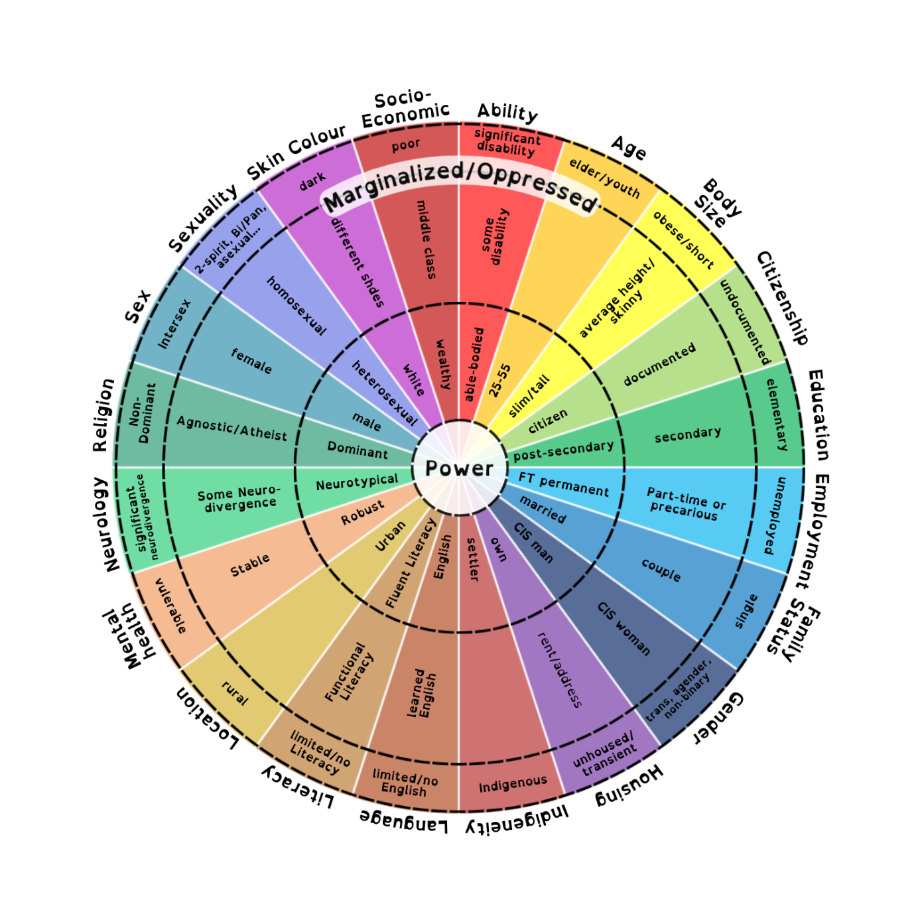

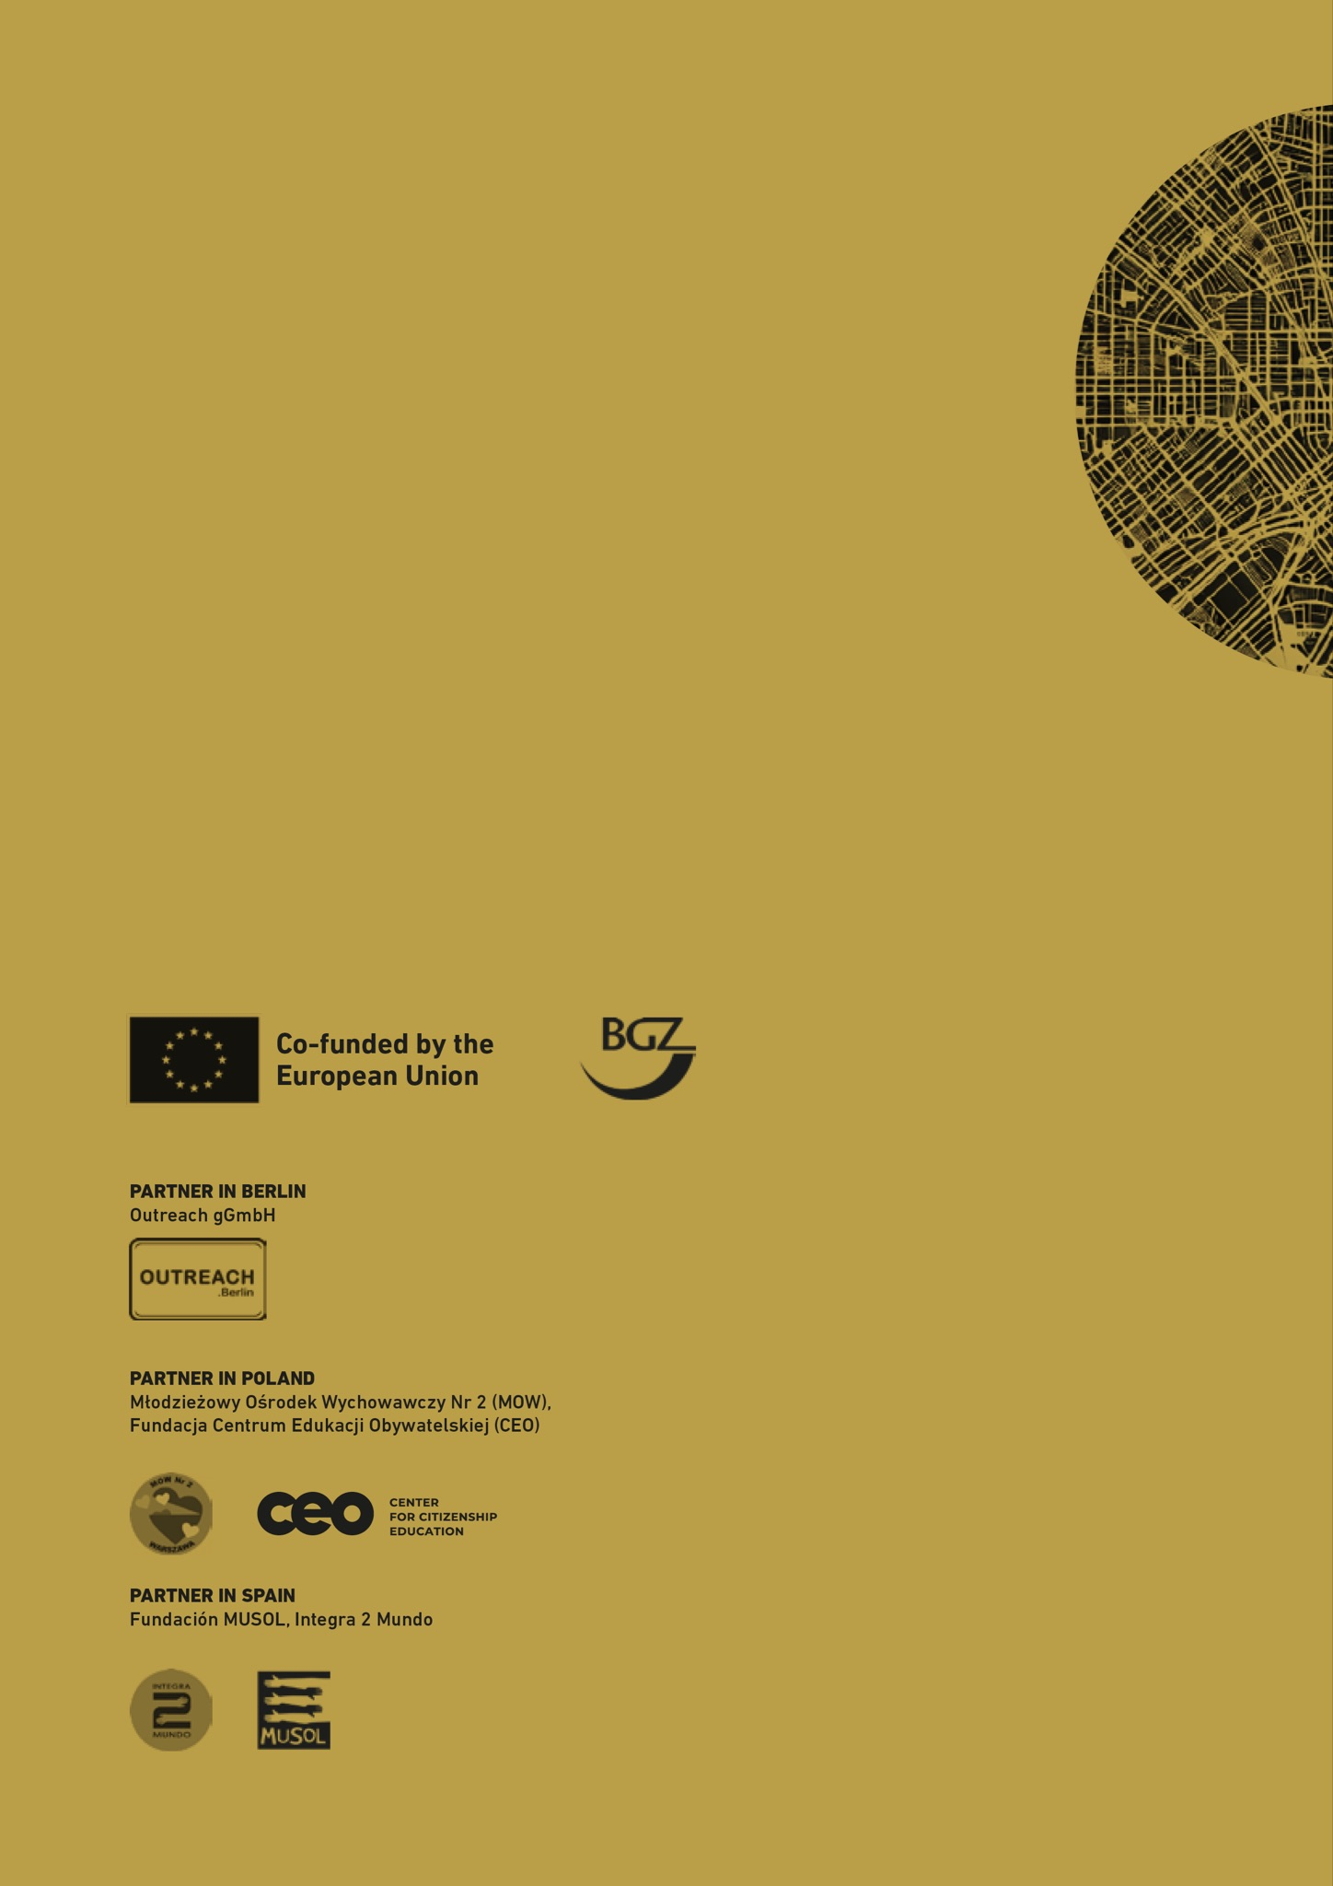



1. I.e., The guiding principles of youth work such as lifeworld-orientation, youth-centeredness, voluntariness, openness, non-formal/informal learning, participation, commitment to social justice, willingness to experiment, etc. must be preserved. Dimensions such as well-being, the experience of autonomy, self-efficacy, and agency are fundamental prerequisites for all forms of educational processes in youth welfare.
2. That means a specific way of thinking about justice that simultaneously emphasizes the equitable distribution of resources and opportunities, the acknowledgment and respect of diverse identities and contributions, the empowerment of individuals and communities to fully participate in societal processes, and the actualization of rights and opportunities for all members of society.